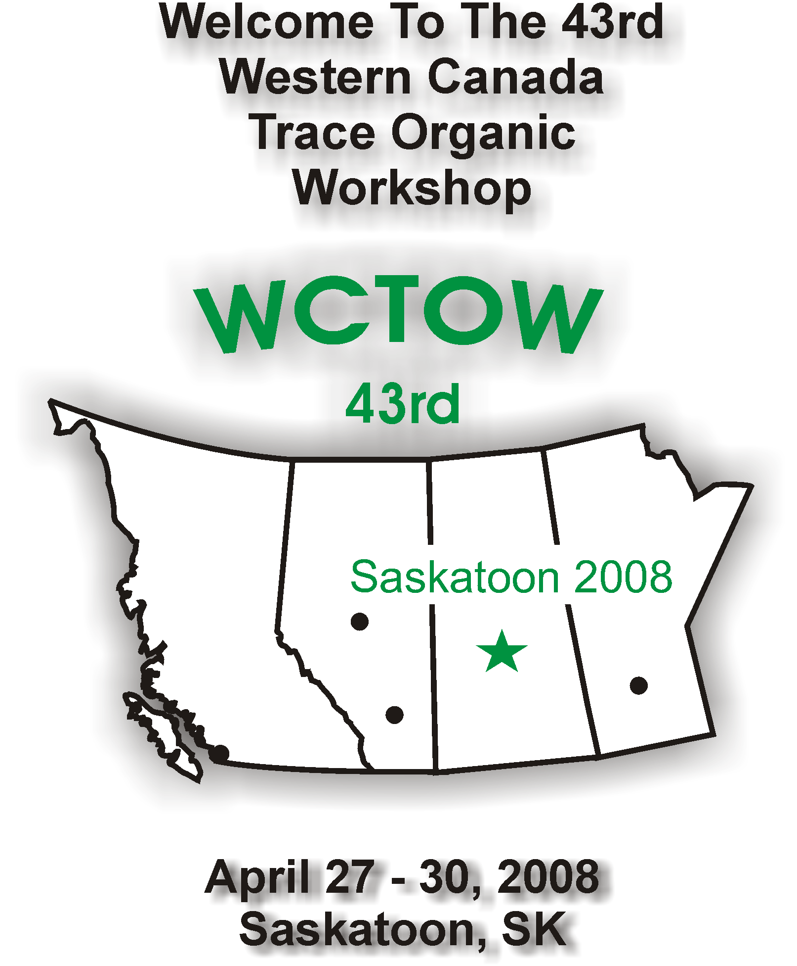

WCTOW 2008 PROGRAM
Delta Bessborough,
601 Spadina Cres, Saskatoon SK.
306-244-5521

Day 1, Sunday, April 27, 2008

6:00 – 9:00pm | Corporate Display &  Scientific Poster Set-Up | Battleford Room
7:00 – 8:00pm | Registration  (Cheques or cash, no credit cards) | Terrace Lounge
7:00 – 11:00pm | Social Mixer | Terrace Lounge

Day 2, Monday, April 28, 2008

8:00am  8:00am | Registration (Cheques or cash, no credit cards) and Poster Set-Up  Continental Breakfast – Sponsored by Applied Biosystems/MDS Sciex | Battleford Room  Battleford Room
8:55am | Welcome and Introduction | Kerry Peru

Session #1 Chairperson – Kerry Peru (Environment Canada)

9:00am | LC/TOF and Q/TOF-MS Analysis of Pesticides in Food and Water | E. Michael Thurman  (U. Colorado)
9:45am | Sample Handling Challenges for Determination of Ochratoxin A in Wheat | Tom Nowicki (Canadian Grain Commission)
10:15am | A Generic Method for the Direct Injection of Water Samples to Analyze Pesticides at Concentrations of 0.1μg/L Using LC/MS/MS | Hesham Ghobarah (Applied Biosystems/MDS Sciex)

Day 2, Monday, April 28, 2008, Continued

10:45am | Morning Coffee Break – Sponsored by Thermo Scientific | Battleford Room

11:00am – 12:00 - Poster Presentations (authors in attendance)

12:00noon | Buffet Lunch – Sponsored by  Agilent Technologies | Terrace Lounge

Session #2 Chairperson – John Headley (Environment Canada)

1:30pm | Investigation of Carboxylic Acids In Aqueous Solution: An Electrospray Mass Spectrometry Study | Lee Wilson  (U of S)
2:00pm | Photocatalytic Degradation of Naphthenic Acids by Titanium Dioxide (TiO₂) | Jing-Long Du (EC, Saskatoon)
2:30am | Development of a New Column and Method for the Measurement of Haloacetic Acids in Drinking Water by IC/MS and IC/MS/MS | Clayton Babcock  (Dionex)

3:00pm | Afternoon Coffee Break – Sponsored by Canadian Life Science | Battleford Room

3:30pm | Misadventures in Mass Spectrometry II: Curse of the Phospholipids | Tom Thompson  (Alberta Agriculture)
4:00pm | Free and Total Glycerin in B100 BioDiesel | Miles Snow  (Perkin Elmer)

Day 3, Tuesday, April 29, 2008

8:00am | Continental Breakfast – Sponsored by  Mass Spec Consulting | Battleford Room
8:40am | Introduction | Allan Cessna

Session #3 Chairperson – Allan Cessna (AAFC/ Env. Canada)

8:45am | QuEChERS (Quick, Easy, Cheap, Effective, Rugged and Safe Approach for Determining Pesticide Residues | Don Shelly (UCT)
9:15am | Application of the QuEChERS Extraction Method for the Analysis of Pyrethrins and Pyrethroids in Fin and Non-Fin Fish | Veronica Roscoe  (Health Canada,  Winnipeg)
9:45am | Determination of Herbicide Residues in Wetland Sediments using LC/MS/MS | Dani Xu  (U of S)
10:15am | Accurate mass ESI-Tof plus Isotope Profile as an alternate to SRM ? | Mike McDonell  (Bruker)
10:45am | Morning Coffee Break – Sponsored by Isomass | Battleford Room

11:00am – 12:00 - Corporate Displays (with reps in attendance)

12:00noon | Buffet Lunch – Sponsored by  Bruker Daltonics Canada | Terrace Lounge

Day 3, Tuesday, April 29, 2008 Continued

Session #4 Chairperson – Brad McPherson (Env. Canada)

1:15pm | Moving a Method from GC/NPD to LC/MS: Drugs in Urine | Ralph Hindle  (Vogon Laboratory Services)
1:45pm | Persistence of Antimicrobials in Beef Cattle Manure during Composting | Sandra Kutcha (AAFC, Saskatoon)
2:15pm | Detection of Diclazuril Poultry Feed Additive by LC/MS | Vesna Furtula (PESC EC, Vancouver)
2:45pm | Multiresidue Screening of Agricultural Chemicals in Food Matrix using Varian SPE and Triple Quadrupole LC-MS/MS | Marcus Kim (Varian)

3:15pm | Afternoon Coffee Break – Sponsored by Dionex Canada Inc. | Battleford Room

3:30pm | Principles and Application of the Biacore Immunochemical Biosensor Instrument to the Screening of Animal Tissues for Residues of Veterinary Drugs | Les Dickson  (CFIA, Saskatoon)

4:00 – 5:00pm | Corporate Display &  Scientific Poster Removal | Battleford Room

Day 3, Tuesday, April 29, 2008 Continued

Evening Banquet and Entertainment
(TCU Place & Persephone Theatre)

(Sponsored by Varian Canada Inc.)

5:00pm | Cash Bar opens at Teacher’s Credit Union Place
5:45pm | Banquet – sponsored by Varian Canada Inc.
7:30pm | Walk to Persephone Theatre for play Berlin Blues
8:00pm | Showtime for Berlin Blues by Drew Hayden-Taylor

Day 4, Wednesday, April 30, 2008

8:00am | Continental Breakfast – Sponsored by  Applied Biosystems/MDS Sciex | Battleford Room
8:55am | Introduction | Tom Thompson

Session #5 Chairperson – Tom Thompson (Alberta Agriculture)

9:00am | Emergency Preparedness: Rapid Screening of Potentially Deleterious Organics in Unknown Environmental Samples | Dayue Shang (Environment  Canada, Vancouver)
9:30pm | Optimization Of A Method – Quicker Ways To Reach Your Goal | Christine Akre (CFIA, Saskatoon)
10:00am | Effects of Agriculture Use on Adjacent Streams: Partitioning of Pesticide Residues in Sediment Laden Water Samples | Mélaine Thibodeau  (Environment Canada, Moncton)

Day 4, Wednesday, April 30, 2008 Continued

10:30am | Morning Coffee Break – Sponsored by Perkin Elmer | Battleford Room

11:00am | The Emergence of Tandem Quadrupole Mass Spectrometers as a Routine Tool in Quantitative GC/MS/MS Applications | Doug Stevens  (Waters)
11:30am | Fast Multi-component Pesticide Analysis using GC-MS/MS | Hans-Joachim Heubschmann (Thermo Scientific)
12:00noon | Workshop Business Meeting  (all welcome) | Battleford Room

12:10pm | Buffet Lunch – Sponsored by  Waters Limited | Terrace Lounge

Thanks for Attending!

Have A Safe Trip Home!

See You Next Year in Winnipeg!

Poster Presentations:

The Determination of Chlormequat Chloride (Chlormequat) in Cereal Crops using ASE Extraction and LC/MS/MS Analysis | Dainna Drul  (Canadian Grain Commission)
Detection of Ethanesulfonic Acid and Oxanilic Acid Degrates of Chloracetanilides and other Acetamide Herbicides in Drinking Water by LC/MS/MS | Hesham Ghobarah  (Applied Biosystems/MDS Sciex)
New C18 Solid-phase Extraction Cartridge for Semi-Volatile Organic Compounds (EPA Method 525.2) | Don Shelly  (UCT/Chromatographic Specialties)

Finding the needle in the haystack: The effect of sample matrix on quantitation using Liquid Chromatography Mass Spectrometry | Johanna Chrusch  (CFIA Saskatoon)
Evaluation of Randox Sulfonamide Test Kit in Laboratory Study | Jana Kinar  (CFIA Saskatoon)
Advances in Food Safety and Nutritional Quality Assurance | Doug Stevens (Waters)
Ceftiofur Residues in Milk by LC/MS/MS | Gwen Fernandes  (CFIA Calgary)

